Report for Code Testing Software Quality Assurance

CSCS 351 – Awais Akram Malik 221440873

I ran the following code to record employee details including name, salary raise and monthly schedule.

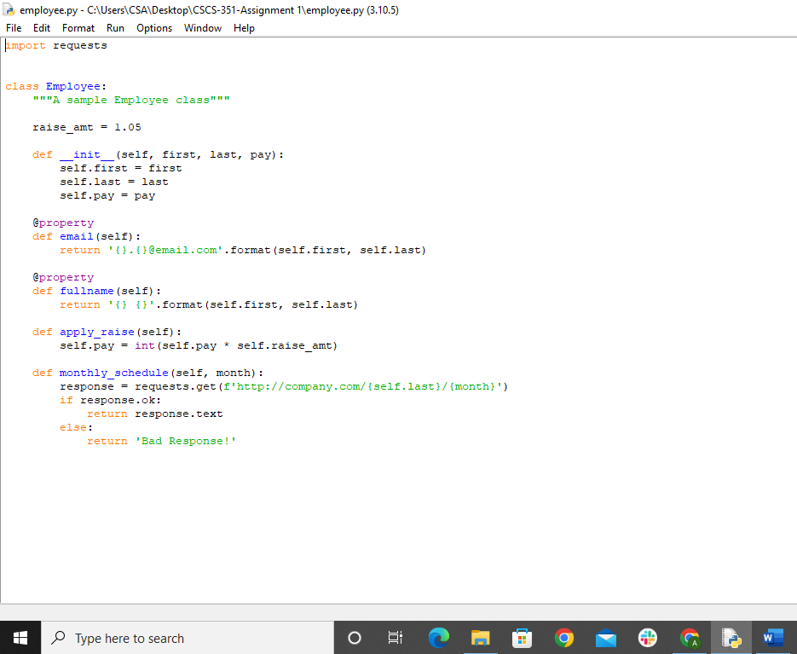

The Following was the test code to make sure the code that a produced was actually running successfully

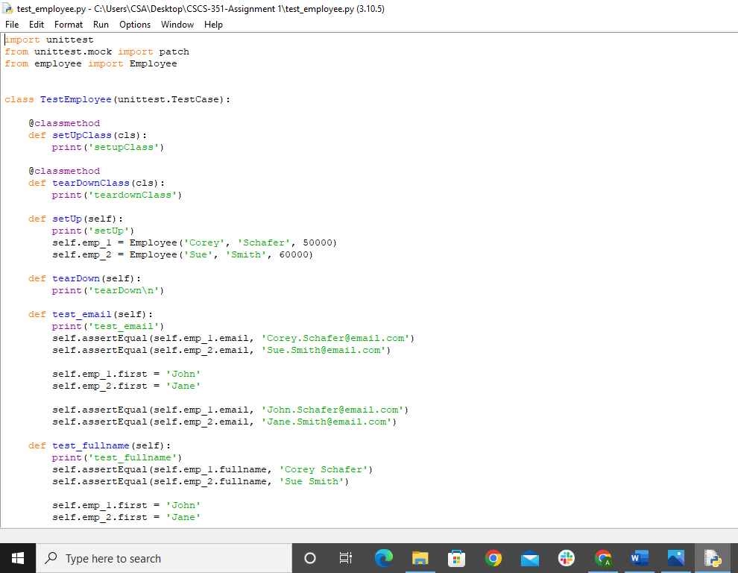

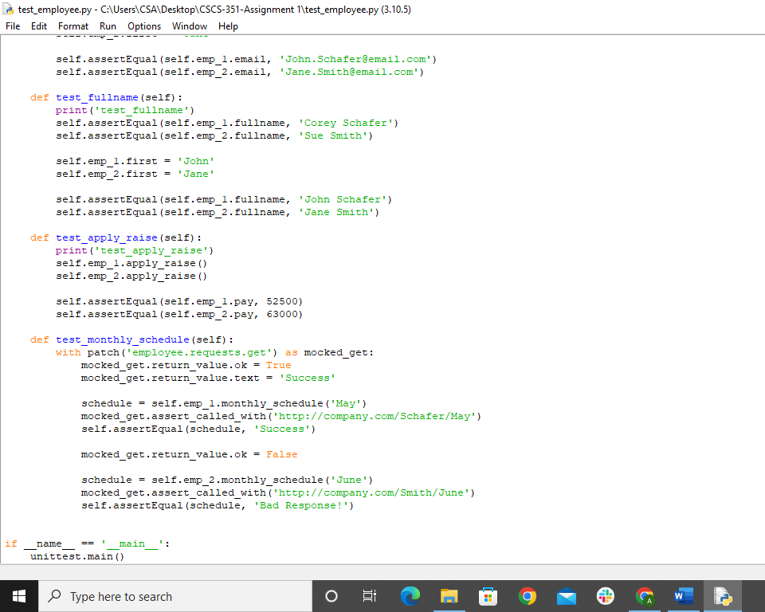

ON successfully running the code, the following message was displayed. It says that 5 tests were run and the result is OK, indicating the code is flawless in executing its calculations

